**Ex. No:7 Roll No: 230701374**

**Date:28/08/2024 Name: VELAN A**

Using Set Operators

1. The HR department needs a list of department IDs for departments that do not contain the job ID ST_CLERK. Use set operators to create this report.

# SELECT DEPARTMENT_ID FROM JOB MINUS SELECT DEPARTMENT_ID FROM JOB WHERE JOB_ID='Clerk';

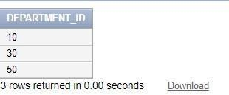

1. The HR department needs a list of countries that have no departments located in them. Display the country ID and the name of the countries. Use set operators to create this report.

# SELECT COUNTRY_NAME,COUNTER_ID FROM JOB MINUS SELECT COUNTRY_NAME,COUNTER_ID FROM JOB WHERE DEPARTMENT_ID IS NULL;

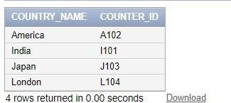

1. Produce a list of jobs for departments 10, 50, and 20, in that order. Display job ID and department ID using set operators.

# SELECT JOB_ID,DEPARTMENT_ID FROM JOB WHERE DEPARTMENT_ID= 10 UNION SELECT JOB_ID,DEPARTMENT_ID FROM JOB WHERE DEPARTMENT_ID= 50 UNION SELECT JOB_ID,DEPARTMENT_ID FROM JOB WHERE DEPARTMENT_ID= 20;

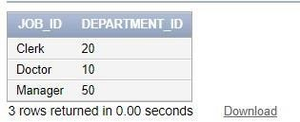

1. Create a report that lists the employee IDs and job IDs of those employees who currently have a job title that is the same as their job title when they were initially hired by the company (that is, they changed jobs but have now gone back to doing their original job).

# SELECT EMPLOYEE_ID,JOB_ID FROM JOB INTERSECT SELECT EMPLOYEE_ID,JOB_ID FROM JOB_HISTORY;

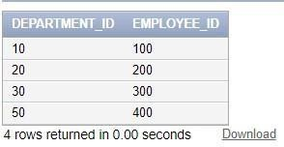

1. The HR department needs a report with the following specifications:
   * Last name and department ID of all the employees from the EMPLOYEES table, regardless of whether or not they belong to a department.
   * Department ID and department name of all the departments from the DEPARTMENTS table,

regardless of whether or not they have employees working in them Write a compound query to accomplish this.

**SELECT DEPARTMENT_ID,EMPLOYEE_ID FROM JOB; SELECT LAST_NAME,DEPARTMENT_ID**

**FROM Dept_Table UNION ALL**

**SELECT NULL AS LAST_NAME,DEPARTMENT_ID FROM JOB;**

